Data Science Laboratory
Project Report
On

“Football Player Performance Analysis”

Submitted By
Group No. 19

Aeldosh Dcosta (5023111)

Course Co-ordinator - Dr. Poonam Bari


Fr. Conceicao Rodrigues Institute of Technology
(An Autonomous Institute & Permanently Affiliated to University of Mumbai)
Sector 9A, Vashi, Navi Mumbai – 400703
Department of Information Technology

2025–2026

1. INTRODUCTION

1.1 Background

The rapid evolution of data analytics has significantly transformed various industries, and sports is no exception [10]. In modern football, data analytics plays a crucial role in enhancing decision-making processes, improving player performance, and optimizing team strategies [1]. With the increasing availability of structured and high-resolution data, football clubs and analysts can now quantify aspects of the game that were previously assessed subjectively [2]. Traditionally, football performance was evaluated using basic statistics such as goals scored, assists, and match outcomes. However, these metrics provide only a limited view of a player’s contribution. The emergence of advanced analytics has introduced sophisticated metrics such as Expected Goals (xG), Expected Assists (xA), passing accuracy, progressive passes, and defensive actions, enabling a deeper understanding of player performance [3,4, 5].Organizations such as professional football clubs, scouting agencies, and sports analytics companies rely heavily on these metrics to assess player efficiency, identify talent, and design match strategies. The integration of data science techniques, including statistical analysis and machine learning, has further enhanced the ability to uncover hidden patterns and trends in player performance data [7, 8].

1.2 Motivation

The increasing competitiveness of modern football has made it essential for teams to adopt data-driven approaches for performance evaluation and decision-making [11]. Traditional scouting and analysis methods are often subjective and may overlook critical aspects of player performance. This project is motivated by the need to develop a systematic and objective framework for analyzing football player performance using data science techniques. By leveraging a comprehensive dataset containing player statistics for the 2024–2025 season [1], this study aims to provide meaningful insights into player contributions across different dimensions of the game. Additionally, the project seeks to address challenges such as identifying high-performing players, understanding performance variability, and evaluating efficiency metrics.

1.3 Problem Definition
Football performance analysis involves handling complex and high-dimensional data consisting of multiple interrelated variables. Metrics such as goals, assists, minutes played, expected goals, and passing statistics interact in non-linear ways, making it challenging to derive meaningful conclusions.
Key challenges include:
- Handling large and complex datasets
- Identifying correlations between multiple performance metrics
- Dealing with skewed distributions and outliers
- Interpreting results in a meaningful and actionable way
Problem Statement:

To design and implement a data analysis pipeline that processes football player performance data and generates comprehensive insights regarding player efficiency, consistency, and overall contribution using statistical and visualization techniques.

1.4 Scope and Assumptions
1.4.1 Scope
The scope of this project includes data preprocessing, exploratory data analysis, feature engineering, and visualization of football player performance metrics. The project may also include basic predictive modeling techniques as an extension.
1.4.2 Assumptions
- The dataset is accurate and reliable
- All player statistics are consistently recorded
- Missing values are minimal and manageable
- The dataset represents real-world player performance.

1.5 Objectives

The primary objectives of this project are:

To analyse the football player performance dataset for the 2024–2025 season

To perform detailed exploratory data analysis (EDA)

To identify relationships between key performance metrics

To develop derived features such as performance efficiency indicators

To visualize patterns and trends in player performance

To provide insights that can support decision-making in football analytics

1.6 Conclusion
This chapter introduced the importance of football analytics and the need for data-driven performance evaluation. The project aims to leverage statistical and analytical techniques to extract meaningful insights from player performance data.

2. LITERATURE SURVEY

2.1 Investigation of Current Field
The rapid growth of data analytics in football has transformed how teams, analysts, and organizations evaluate player performance. Modern football analysis relies heavily on large-scale datasets, such as those provided by FBRef, Opta, and StatsBomb [1, 2, 3], which capture detailed match statistics including passing accuracy, expected goals (xG), defensive actions, and player positioning. Traditionally, methods of evaluating players—such as manual observation and basic statistics like goals and assists—are increasingly insufficient for capturing the complete performance of a player [5]. These approaches often fail to account for contextual and advanced metrics such as expected assists (xA), pressing efficiency, and contribution to build-up play [6]. Recent advancements in sports analytics have introduced machine learning and statistical modeling techniques to evaluate player performance more comprehensively [7, 8]. Models such as regression analysis, clustering, and player similarity algorithms are widely used to identify patterns, rank players, and predict future performance [10]. However, several challenges remain. Many existing approaches rely on limited datasets, lack standardization across leagues, or fail to integrate multiple performance dimensions into a unified framework. Additionally, the dynamic and context-dependent nature of football makes it difficult to generalize models across different competitions and playing styles [11, 12]. Therefore, there is a clear need for a data-driven, scalable, and interpretable system that can analyze player performance using comprehensive datasets like the FBRef 2024–2025 dataset, motivating the present work.
2.2 Related Work
Recent research in football analytics highlights the increasing use of data-driven approaches to evaluate player performance. Studies have utilized datasets similar to FBRef to analyze key performance indicators such as goals, assists, passing accuracy, and defensive contributions [1]. Machine learning models such as Linear Regression, Random Forest, and Gradient Boosting have been applied to predict player performance metrics and team outcomes [2, 8]. These models help in identifying high-performing players and uncovering hidden patterns in large datasets. Clustering techniques like K-Means have also been used to group players based on playing style and role similarity [4]. Advanced metrics such as Expected Goals (xG) and Expected Assists (xA) have gained significant importance in recent years [3]. These metrics provide a more accurate representation of a player’s contribution compared to traditional statistics. However, they also introduce challenges such as data complexity and dependency on accurate event tracking systems. Several studies emphasize the importance of feature engineering, including the normalization of statistics per 90 minutes [5], and adjustment for team strength and league difficulty [7]. Data visualization techniques such as heatmaps, radar charts, and correlation matrices are also widely used to interpret player performance [6]. Despite these advancements, limitations still exist. Many models focus on single aspects of performance (e.g., attacking metrics only), lack interpretability, or fail to generalize across different leagues and seasons. Additionally, handling missing data, inconsistencies, and high dimensionality remains a challenge [9, 10]. This project builds upon these works by utilizing a comprehensive football dataset and applying data analysis and machine learning techniques to evaluate multiple aspects of player performance in an integrated manner.
2.3 Existing System
Current football player performance analysis systems, especially those used by clubs and analysts, rely on a combination of statistical dashboards, manual scouting, and basic data visualization tools. While these systems provide useful insights, they often lack automation, scalability, and advanced analytical capabilities.
2.3.1 Features of Existing System:
- Basic Statistical Analysis: Most systems focus on traditional metrics such as goals, assists, and appearances.
- Manual Evaluation: Player performance is often interpreted manually by analysts or scouts.
- Limited Visualization: Basic charts and tables are used without deeper analytical insights.
- Single-Dimensional Analysis: Systems often evaluate attacking, defensive, or passing metrics separately rather than combining them.
2.3.2 Limitations of Existing System:
- Lack of Advanced Metrics Integration: Metrics like xG, xA, and pressing stats are not always fully utilized.
- Poor Generalization: Models trained on specific leagues may not perform well across others.
- Data Inconsistency: Missing values and varying data formats affect analysis quality.
- Limited Automation: Most systems require manual intervention for data processing and analysis.
- No Holistic Evaluation: Players are not evaluated across multiple dimensions simultaneously.
2.3.3 Functional Requirements
- Data Preprocessing Pipeline: The system must clean, normalize, and preprocess the FBRef dataset.
- Multi-Metric Analysis: The system should analyze multiple performance metrics such as attacking, passing, and defensive stats.
- Player Comparison Module: Ability to compare players based on selected features.
- Visualization Dashboard: Provide graphs such as correlation matrices, bar charts, and radar plots.
- Model Integration: Apply machine learning models for prediction and performance evaluation.
2.3.4 Non-Functional Requirements

Scalability: The system should handle large datasets across multiple seasons and leagues.

Efficiency: Data processing and model inference should be fast and optimized.

Usability: The interface should be simple and user-friendly.

Flexibility: The system should allow easy addition of new features and metrics.

Reliability: The system should handle missing or inconsistent data effectively.

2.4 Summary of Literature Resources
The Table 2.4.1 summarizes the reviewed literature and existing approaches in football analytics, highlighting their key contributions, limitations, and the improvements proposed in this project using the FBRef 2024–2025 dataset.

Table 2.1 – Comparative Analysis of All 12 Literature Resources
Ref. | Summary | Problems / Gaps Identified | Proposed Improvements
[1] | Use of FBRef and similar datasets for detailed player statistics collection. | Limited dataset coverage across leagues and seasons; missing contextual features. | Use a comprehensive dataset with consistent preprocessing and feature integration.
[2] | Application of machine learning models such as Random Forest and Regression for player performance prediction. | Models focus on limited performance metrics and lack interpretability. | Use multi-metric evaluation combining attacking, defensive, and passing features.
[3] | Use of Expected Goals (xG) and Expected Assists (xA) for advanced performance analysis. | Dependency on accurate event data and difficulty in interpretation | Combine advanced metrics with traditional statistics for balanced evaluation..
[4] | Clustering techniques (K-Means) to group players based on playing style | Clusters may not generalize across leagues or tactical systems. | Include normalized and standardized features to improve clustering accuracy.
[5] | Use of per 90-minute statistics for fair comparison of players. | Does not fully account for team strength or match context. | Incorporate additional contextual and performance-based features.
[6] | Data visualization techniques such as radar charts and heatmaps for performance analysis. | Visualizations lack predictive insights and automation. | Integrate visualization with machine learning outputs for better insights.
[7] | Feature engineering and normalization techniques for sports datasets. | High dimensionality and redundancy in features. | Apply feature selection and correlation analysis to reduce complexity.
[8] | Multi-output models for predicting multiple performance indicators simultaneously. | Correlation between targets may introduce prediction errors.. | Use balanced models and proper evaluation metrics to handle dependencies.
[9] | Use of dashboards and analytics platforms for player performance monitoring. | Lack of real-time analysis and scalability. | Develop scalable and interactive dashboards with automated updates.
[10] | Cross-validation techniques for model evaluation in sports analytics.. | Improper validation may lead to overfitting. | Apply robust validation techniques for reliable performance evaluation.

3. EXPLORATORY DATA ANALYSIS (EDA)
A comprehensive exploratory data analysis (EDA) was conducted to understand the structure, distribution, and relationships within the FBRef Football Player Performance 2024–2025 dataset. This analysis helps in identifying patterns, handling data inconsistencies, and selecting relevant features for modeling and evaluation..
3.1 Dataset Description

The dataset used in this project is sourced from FBRef [1] and contains detailed statistics of football players from the 2024–2025 season across multiple leagues. It includes a wide range of performance metrics such as goals, assists, shots, passes, defensive actions, and advanced statistics like Expected Goals (xG) and Expected Assists (xA) [3, 4]. Each record in the dataset represents a player’s performance over a season and includes attributes such as player name, team, position, matches played, minutes played, and multiple performance indicators. The dataset captures real-world variability in player roles, playing styles, and team strategies, making it suitable for in-depth analysis and modeling.The dataset consists of numerous numerical and categorical features, enabling multi-dimensional evaluation of player performance.

3.2 Dataset Structure and Overview
The dataset is organized in a tabular format where each row corresponds to an individual player and columns represent different performance metrics. These features can be broadly categorized into:
- Basic Information: Player name, team, league, position
- Playing Time Metrics: Matches played, minutes played
- Attacking Metrics: Goals, assists, shots, shots on target
- Passing Metrics: Pass attempts, pass accuracy, key passes
- Defensive Metrics: Tackles, interceptions, blocks
- Advanced Metrics: Expected Goals (xG), Expected Assists (xA)
Before analysis, the dataset was cleaned by handling missing values, removing duplicate records, and ensuring consistency in feature formats. Additionally, some features were normalized (e.g., per 90 minutes) to allow fair comparison between players with different playing times.
3.3 Distribution Analysis of Key Features:
The distribution of key performance metrics such as goals, assists, and xG was analyzed to understand their spread across players. As illustrated in Figure 3.1 and Figure 3.2, it was observed that most features follow a heavily right-skewed distribution, where a majority of players have low values and a small number of players exhibit very high performance. This severe right-skewness is mathematically confirmed, with Goals exhibiting a skewness of 3.62 and Assists showing a skewness of 2.69.
For example:
- Goals and assists are concentrated among a few top-performing players
- Defensive metrics like tackles and interceptions vary based on player position
- Passing accuracy tends to be more normally distributed
To handle skewness and improve analysis, normalization and scaling techniques were applied where necessary. This ensures that extreme values do not dominate the analysis and helps in building more stable models.
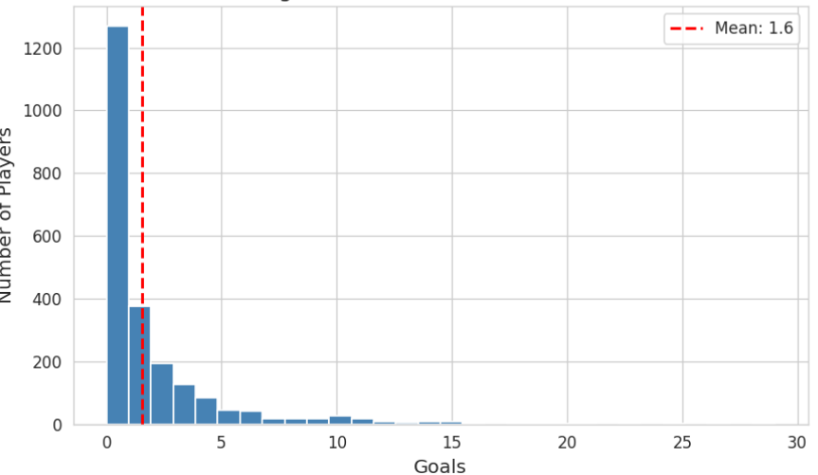
Figure 3.1: Distribution of Goals among Players

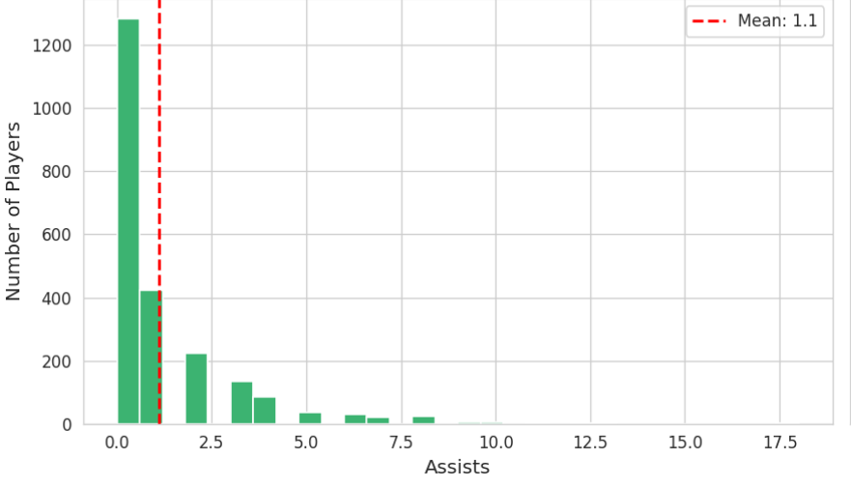Figure 3.2: Distribution of Assists among Players
3.4 Correlation Analysis Between Features
A correlation analysis was performed to identify relationships between different performance metrics. As shown in the Figure 3.3 correlation matrix, several important insights were revealed:
- Strong positive correlation between goals and xG, indicating that expected goals are a reliable indicator of scoring performance
- Moderate correlation between assists and key passes, reflecting creative playmaking ability
- Defensive metrics such as tackles and interceptions show correlation within defensive roles
- Weak correlation between unrelated metrics (e.g., goals and tackles), indicating distinct player roles
These relationships justify the use of multi-feature analysis, as player performance cannot be evaluated using a single metric. Correlation analysis also helps in feature selection by identifying redundant or highly dependent variables.
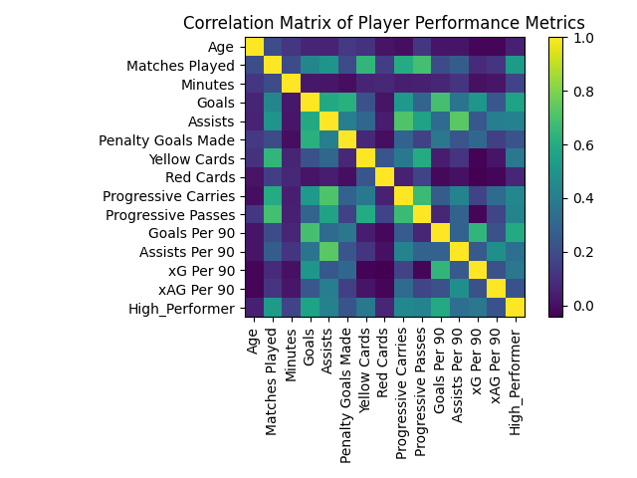
Figure 3.3: Correlation Matrix of Player Performance Metrics

3.5 Analysis of Advanced Metrics
Advanced metrics such as Expected Goals (xG) and Expected Assists (xAG) were analyzed to understand deeper performance patterns. These metrics provide context beyond traditional statistics by estimating the quality of scoring opportunities and chance creation. The analysis, visualized in the scatter plot of Figure 3.4, showed that:
The analysis showed that:
- Players with high xG but lower actual goals may be underperforming or unlucky
- Players exceeding their xG values may indicate high finishing efficiency
- xA provides a better measure of creativity compared to raw assist counts
Furthermore, as demonstrated in Figure 3.4, xA provides a better measure of actual creativity compared to raw assist counts. Combining these advanced metrics with traditional statistics provides a more balanced evaluation.
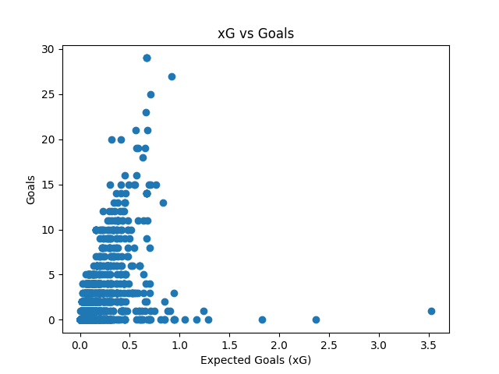Figure 3.4: Relationship between Expected Goals (xG) and Actual Goals
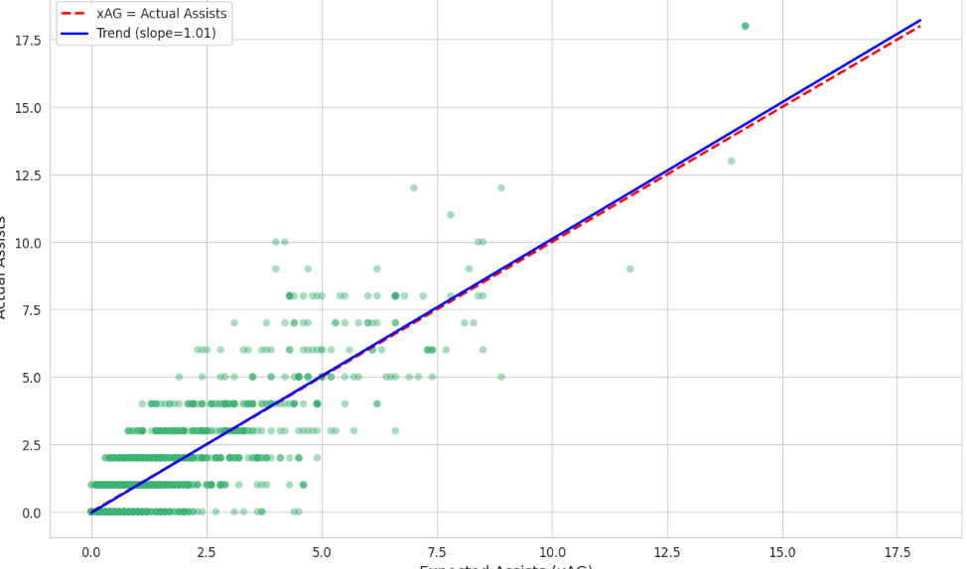
Figure 3.5: xAG vs Actual Assists

3.6 Categorical Feature Analysis
Categorical variables such as team, league, and player position were analyzed to understand their impact on performance. Figure 3.6 highlights the top 10 individual performers by goals, showcasing the elite outliers in the dataset. Additionally, Figure 3.7 demonstrates position-based differences in scoring output:Position-based differences:
  - Forwards show higher goals and xG
  - Midfielders contribute more in passing and assists
  - Defenders excel in tackles and interceptions
- League variability:
Different leagues show variations in playing style, affecting player statistics

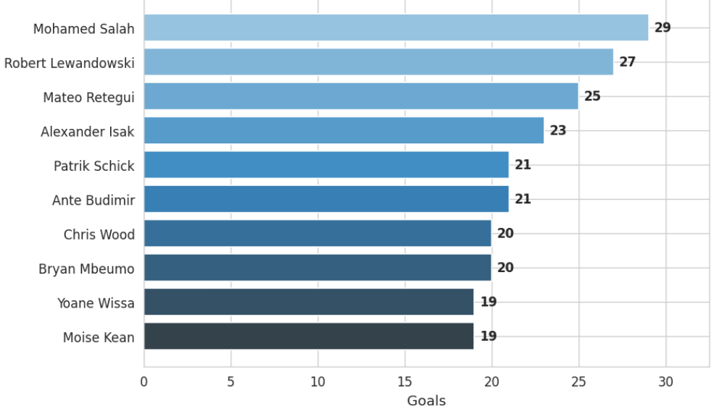
Figure 3.6: Top 10 Players
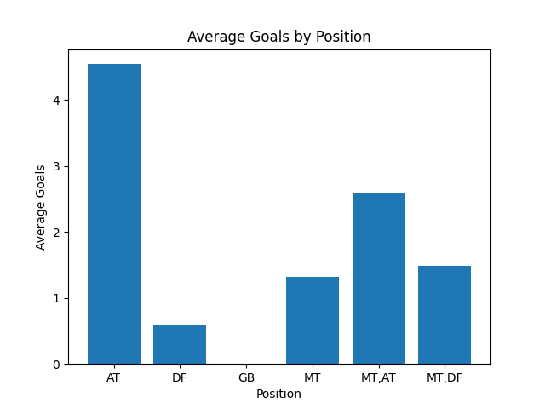
Figure 3.7: Average Goals by Player Position

3.7 Data Quality and Preprocessing Insights

During EDA, several data quality issues were identified and addressed:
- Missing Values: The missing value analysis revealed exactly 0 missing values across the total 1991 players after deduplication, indicating a highly reliable dataset.
- Inconsistent Formats: Standardization was applied to ensure uniform data representation (e.g., removing commas from the 'Minutes' column and converting it to numeric data).
- Outliers: Extreme values were analyzed using the Interquartile Range (IQR) Method and treated carefully to avoid bias.
- Feature Scaling: Applied normalization techniques (such as per-90 metrics) for fair comparison. These preprocessing steps improve the reliability and accuracy of subsequent analysis and modeling.

3.8 Key Insights from EDA
The exploratory data analysis provided several important insights:
- Player performance metrics are highly skewed, with a few players dominating key statistics
- Strong correlations exist between related metrics such as goals and xG, and assists and key passes
- Advanced metrics like xG and xA provide deeper insights into player performance
- Player roles significantly influence statistical patterns
- Data preprocessing and normalization are essential for accurate analysis
These insights form the foundation for building robust analytical models and enable a comprehensive evaluation of football player performance.

REFERENCES
[1] FBref. (2025). Football Player Performance Data 2024–2025 Season. Available at: https://fbref.com/
[2] StatsBomb. (2024). Open Data for Football Analytics. Available at: https://statsbomb.com/
[3] Opta Sports. (2024). Advanced Football Statistics and Analytics. Available at: https://www.optasports.com/
[4] Rathke, A. (2017). An examination of expected goals and shot efficiency in soccer. Journal of Human Sport and Exercise, 12(2), 514–529.
[5] Decroos, T., Bransen, L., Van Haaren, J., & Davis, J. (2019). Actions speak louder than goals: Valuing player actions in soccer. Proceedings of the 25th ACM SIGKDD International Conference on Knowledge Discovery & Data Mining.
[6] Fernández, J., & Bornn, L. (2018). Wide Open Spaces: A statistical technique for measuring space creation in professional soccer. MIT Sloan Sports Analytics Conference.
[7] Liu, G., Schulte, O., Zhu, W., & Li, Q. (2020). Deep learning for player performance evaluation in soccer. Machine Learning Journal.
[8] Berrar, D., Lopes, P., & Dubitzky, W. (2019). Incorporating domain knowledge in machine learning for soccer outcome prediction. Machine Learning and Knowledge Discovery in Databases.
[9] Pappalardo, L., Cintia, P., Rossi, A., Massucco, E., Ferragina, P., Pedreschi, D., & Giannotti, F. (2019). A public data set of spatio-temporal match events in soccer competitions. Scientific Data, 6(1), 236.
[10] Gudmundsson, J., & Horton, M. (2017). Spatio-temporal analysis of team sports. ACM Computing Surveys, 50(2), 1–34.
[11] Rein, R., & Memmert, D. (2016). Big data and tactical analysis in elite soccer: Future challenges and opportunities. Springer.
[12] Link, D., Lang, S., & Seidenschwarz, P. (2016). Real-time quantification of dangerousity in football using spatiotemporal tracking data. PLOS ONE, 11(12).

